a wireframe and high-fidelity layout concept for the real estate app:
- A clean header with Arabic navigation and call-to-action buttons
- A central search bar with dropdowns for location, price, type, and bedrooms
- A 360° virtual tour section to showcase immersive property views
- Featured property listings with visual cards and Arabic labels
- Icons and sections for advanced search, property management, and more

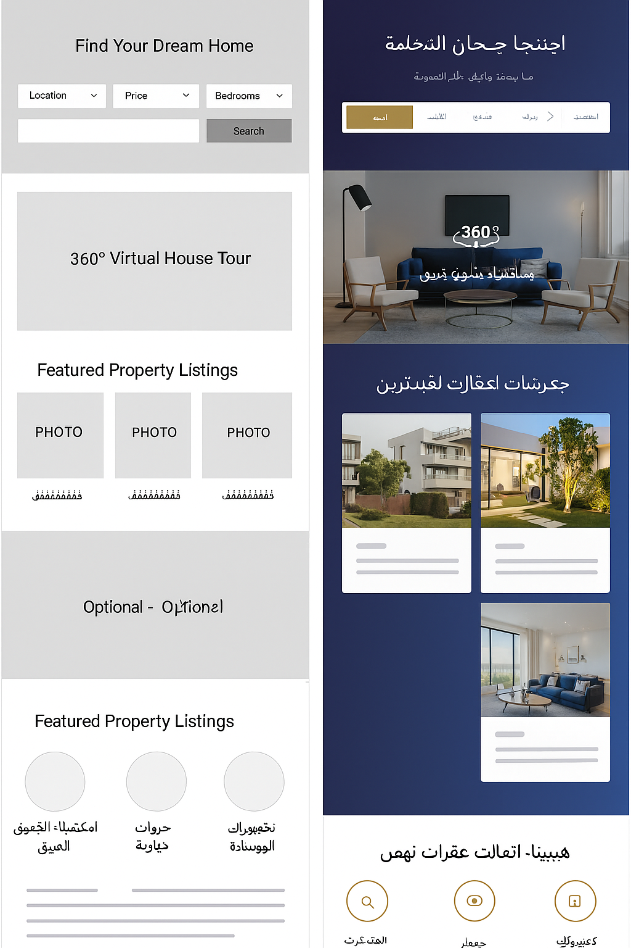

it highlights the core features envisioned:
- 🌀 360° Virtual Tours
- 📊 Market Analysis by Location
- 🏖️ Short-Term Vacation Rentals
You’ll see a structured layout with:
- A deep blue and gold color scheme for trust and elegance
- Arabic navigation and search filters for location, price, and property type
- A hero section with a bold call to action
- Featured property cards with clean visuals
- Icon-based sections for advanced search, tours, and property management

